Mother Shruti(Vedas):
Ekoham bahusyami (Lord Vishnu wanted to manifest Himself in different forms)
Lotus appeared from His naval and he created Lord Brahma and gave him a job to create a universe where a lot like Him can flourish.
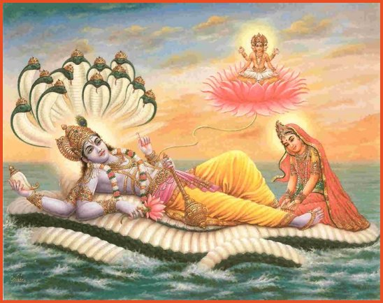

Lord Brahma created 5 essential elements (earth, sky, water, air, fire). The atoms of which combined with one another and formed physical bodies.
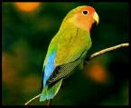
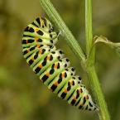

Lord Brahma then made them alive by putting Life Force (Pran-Fraction of God) in each of them.
Lord Brahma created 24 syllable Mantra (the great Gayatri Mantra) to guide for how to live life; Our politics, economics, health, Dharma, desires etc. ||Om bhur bhuvah swah tat savitur varenyam bhargo devasya dheemahi dhiyo onah prachodayat ||
People heard the meaning of each syllable of this greatest mantra in divine voice (Shrvan – hearing). They explained it to others. Thus a lot of knowledge ccumulated.
Risi Krishnadwaipayan Vyasa – compiled all knowledge into four classes: Rigveda(Dharma), Samveda(Desires), Yajurveda(Politics), Atharvaveda(Economics) Thus Vedas are known as Shruties. They are the Brahmgyan, the Ultimate knowledge.

